EXPERIMENT – 6 (F)

import numpy as np

import pandas as pd

# Importing the dataset

dataset = pd.read_csv("/content/IRIS.csv ")

X = dataset.iloc[:, :-1].values

y = dataset.iloc[:, -1].values

# Splitting the dataset into the Training set and Test set

from sklearn.model_selection import train_test_split

X_train, X_test, y_train, y_test = train_test_split(X, y, test_size = 0.25, random_state = 8)

# Feature Scaling

from sklearn.preprocessing import StandardScaler

sc = StandardScaler()

X_train = sc.fit_transform(X_train)

X_test = sc.transform(X_test)

# Training the Decision Tree Classification model on the Training set

from sklearn.tree import DecisionTreeClassifier

classifier = DecisionTreeClassifier(criterion = 'entropy', random_state = 5)

classifier.fit(X_train, y_train)

# Display the Decision Tree

from sklearn.tree import plot_tree

import matplotlib.pyplot as plt

plt.figure(figsize=(20,10))

plot_tree(classifier, filled=True, rounded=True, feature_names=dataset.columns[:-1])

plt.show()

# Predicting the Test set results

y_pred = classifier.predict(X_test)

# Display the results (confusion matrix and accuracy)

from sklearn.metrics import confusion_matrix, accuracy_score

cm = confusion_matrix(y_test, y_pred)

print(cm)

accuracy_score(y_test, y_pred)

**output:**

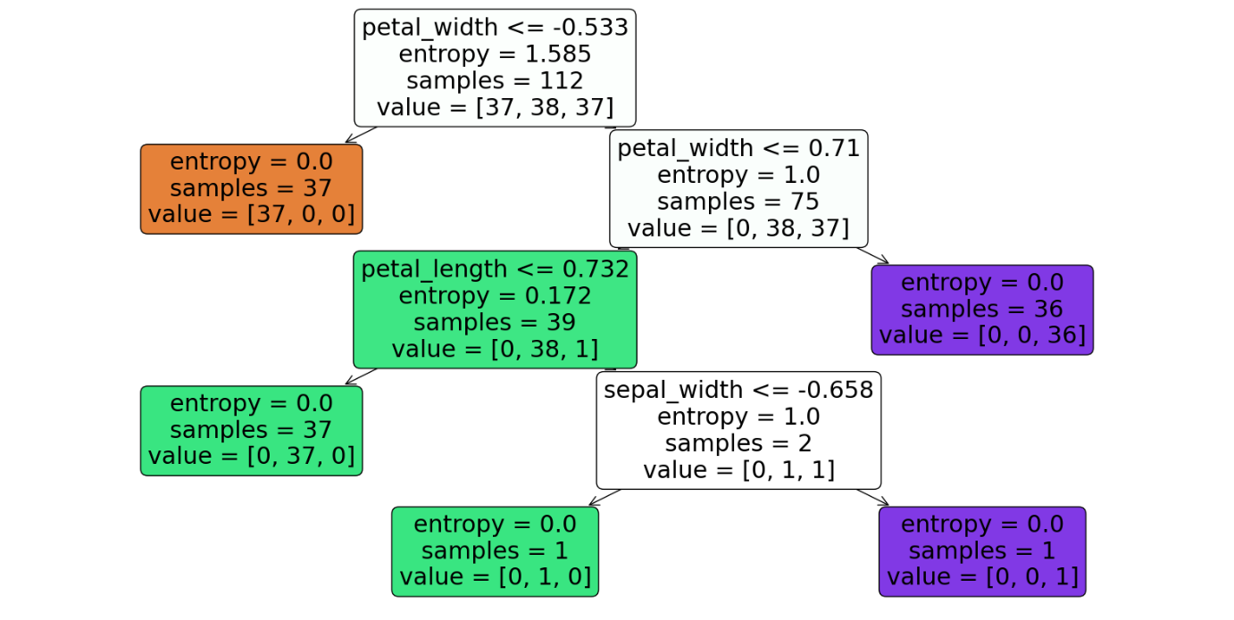

0.8947368421052632

[[13 0 0]

[ 0 11 1]

[ 0 3 10]]

**EXPERIMENT:6(E)SVM**

**AIM: :** finding accuracy value of iris data set using SVM algorithm

**PROGRAM:**

import numpy as np

import pandas as pd

# Importing the dataset

dataset = pd.read_csv("/content/IRIS.csv ")

X = dataset.iloc[:, :-1].values

y = dataset.iloc[:, -1].values

# Splitting the dataset into the Training set and Test set

from sklearn.model_selection import train_test_split

X_train, X_test, y_train, y_test = train_test_split(X, y, test_size=0.25, random_state=32)

# Feature Scaling

from sklearn.preprocessing import StandardScaler

sc = StandardScaler()

X_train = sc.fit_transform(X_train)

X_test = sc.transform(X_test)

# Training the SVM model on the Training set

from sklearn.svm import SVC

classifier = SVC(kernel='linear', random_state=0)

classifier.fit(X_train, y_train)

# Predicting the Test set results

y_pred = classifier.predict(X_test)

# Evaluating the performance of the model using confusion matrix and accuracy

from sklearn.metrics import confusion_matrix, accuracy_score

cm = confusion_matrix(y_test, y_pred)

print(cm)

print('Accuracy: {:.2f}%'.format(accuracy_score(y_test, y_pred) * 100))

**OUTPUT:**

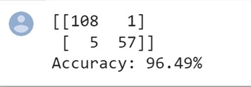

**EXPERIMENT:6(F)RANDOM**

**AIM: :** finding accuracy value of iris data set using RANDOM FOREST algorithm

**PROGRAM:**

import numpy as np

import pandas as pd

# Importing the dataset

dataset = pd.read_csv("/content/IRIS.csv ")

X = dataset.iloc[:, :-1].values

y = dataset.iloc[:, -1].values

# Splitting the dataset into the Training set and Test set

from sklearn.model_selection import train_test_split

X_train, X_test, y_train, y_test = train_test_split(X, y, test_size=0.25, random_state=39)

# Feature Scaling

from sklearn.preprocessing import StandardScaler

sc = StandardScaler()

X_train = sc.fit_transform(X_train)

X_test = sc.transform(X_test)

# Training the Random Forest Classification model on the Training set

from sklearn.ensemble import RandomForestClassifier

classifier = RandomForestClassifier(n_estimators=100, random_state=42)

classifier.fit(X_train, y_train)

# Predicting the Test set results

y_pred = classifier.predict(X_test)

# Making the Confusion Matrix

from sklearn.metrics import confusion_matrix, accuracy_score

cm = confusion_matrix(y_test, y_pred)

print(cm)

print('Accuracy:', accuracy_score(y_test, y_pred))

